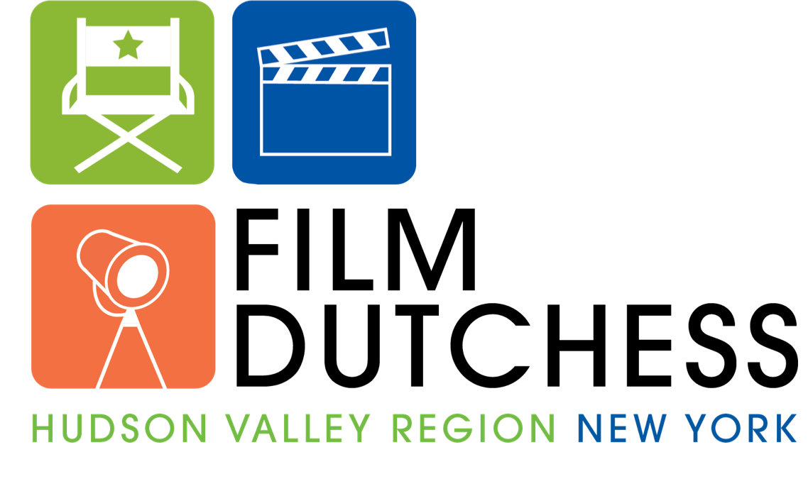
FILM LOCATION INTEREST FORM

This agreement is not a commitment on your part to honor each and every film request that comes to you. All negotiations, fees, and scheduling will be handled by you.

PRIMARY CONTACT NAME:
Day phone: (_____)________________ Night Phone: (_____)________________
Email Address:___________________________________________

SECONDARY CONTACT NAME & EMAIL:
Day phone: (_____)________________ Night Phone: (_____)________________
Email Address:___________________________________________
Property Information

Physical Location Address:

Type of Property (Please circle or bold all that apply)

Home (Modern) Warehouse Hospital/Medical Building

Home (Historic) Office Building School/Classroom

Farm/Farmhouse Apartment Complex Police/Fire Station

Greenspace (Field/Forest) Retail Building Restaurant

Other:_________________________________________________

Property Owner
- Owned by person submitting form
- Other Private Owner
- Other Public Entity
- Non-Profit/Other Organization
- Unknown

Property Owner Name & Contact Information (if different from above)
Name:___________________________________________________________________________
Address:_________________________________________________________________________
Phone Number:________________________
Authorized Signature:______________________________

Please give a brief description of your location, and areas of special interest:

Any restrictions or information that location scouts should know prior to contacting you?

SIGNATURE: __________________________________________ DATE:________________

Photos are required!

Do not trespass on private property to take photos. Up to 10 photos of the property may be submitted and these will be utilized by Dutchess Tourism, Inc. to promote your location and may be used on the Dutchess Tourism website or film page.

Return to: Colleen Dorney, colleen@dutchesstourism.com, 845-463-4000
Dutchess Tourism, Inc. 3 Neptune Road, Suite A11A, Poughkeepsie, New York 12601

